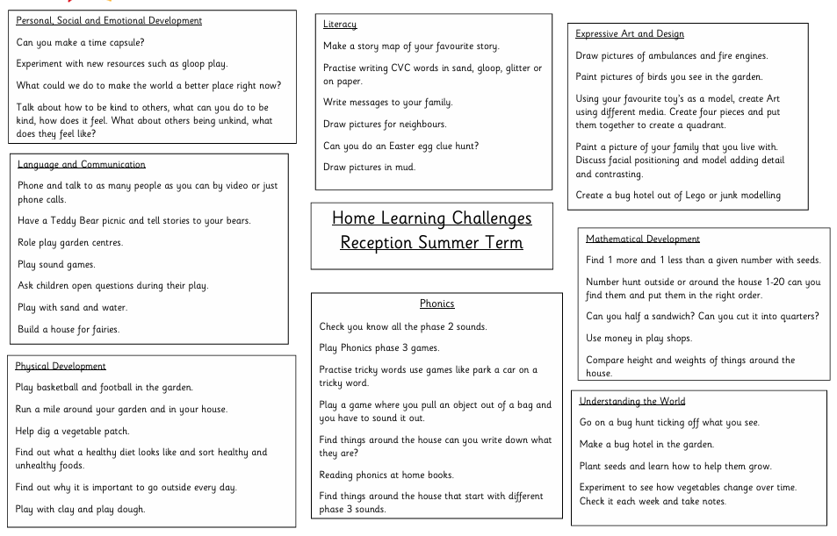
Please send any photographs or videos of your child’s home learning this term to sspp.yearr@taw.org.uk
We would love to give your child the opportunity to talk about their learning and celebrate any achievements.

